**CMPE-250 Laboratory Exercise 5**

**Polled Serial I/O**

By submitting this report, I attest that its contents are wholly my individual writing about this exercise and that they reflect the submitted code. I further acknowledge that permitted collaboration for this exercise consists only of discussions of concepts with course staff and fellow students; however, other than code provided by the instructor for this exercise, all code was developed by me.

Joel Yuhas (RIT Student)

Performed 3/3/2016

Submitted 3/3/2016

Lab Section 02

Instructor: Muhammad Shaaban

TA: Peter Muller

Stephen Moore

Connor Goss

Lecture Section 01

Professor: Sarra Alessandro

**Screen Capture form step 4:**

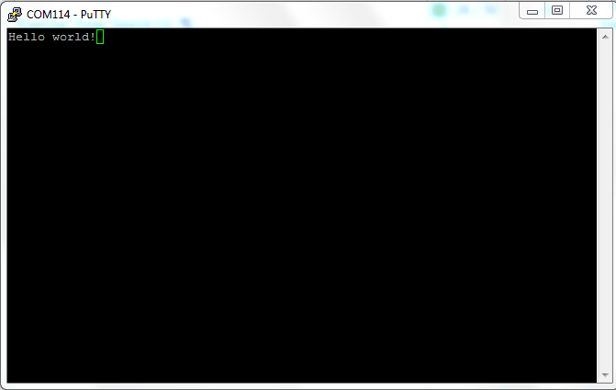

**Answer to the following question:**

*From the KL46 memory map produced for your program, what is the exact memory range, (i.e., the starting address and the address of the last byte), of the executable code you wrote?*

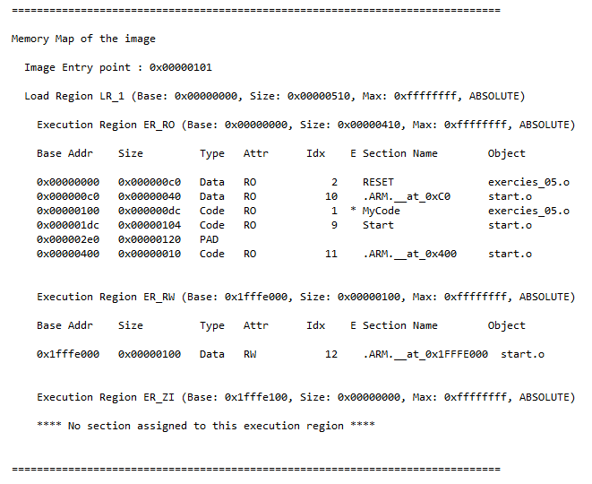Given the following memory map information:

The correct answer for the code I wrote

Is specifically the MyCode Area and

Has a range from:

(Starting) 0x00000100

And

(Ending) 0x000001dc